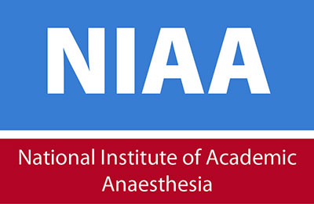 |  | National Institute of Academic Anaesthesia  35 Red Lion Square  London WC1R 4SG  Tel: 020 7092 1542  Return application via email to: hr@rcoa.ac.uk

APPLICATION FORM
Title |  |  |  |  |  | Surname

Forenames
Address for Correspondence |  |  |  | Postcode
Contact daytime Tel/Mobile/Fax No.
Contact evening Tel/Mobile
Email address
Date available to commence employment? (Please also include any intended holiday booked in the next 6 months)

Position Applied For

Statement in Support of your Application
(Please continue on a separate sheet if necessary)
Please indicate clearly why you want the role and how your skills and experience meet the requirements of the post as set out in the Job Description and Person Specification.

Additional Information
Are there any restrictions to you working in the UK? YES/NO

If your answer to the above question is ‘Yes’ please set out any current restrictions below:

Please answer the following question:

Do you have any convictions, cautions reprimands or final warnings that are not “protected” as defined by the Rehabilitation of Offenders Act 1974 (Exceptions) Order 1975 (as amended in 2013). YES/NO
The amendments to the Exceptions Order 1975 (2013) provide that certain spent convictions and cautions are “protected” and are not subject to disclosure to employers, and cannot be taken into account. Guidance and criteria on the filtering of these cautions and convictions can be found on the Disclosure and Barring Service Website.
(Declaration subject to the Rehabilitation of Offenders Act 1974)

If yes, you must provide details:

Please indicate where you saw this post advertised?

Referees
Please give details of at least two referees, who are not related to you.
The referees should be your present (or most recent) employer and one other from previous employment.
1.Name & Title:  Position:  Organisation:  Address:  Email address:  Contact number: | 2. Name & Title:  Position:  Organisation:  Address:  Email address:  Contact number:
Referees will not be contacted prior to interviews.

Declaration
I confirm that the information given on this form is, to the best of my knowledge, true and complete. Any false statement may be sufficient cause for rejection or, if employed, dismissal.

Signature Date:

